JDBC (Java DataBase Connectivity)
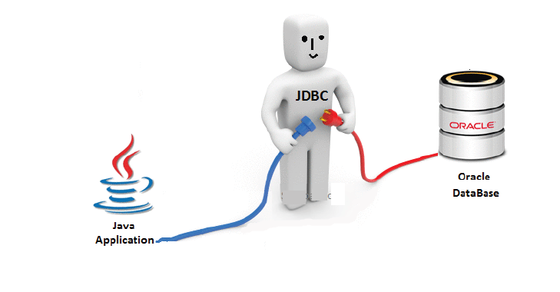
Jdbc is an API (Application programming interface) used to communicate Java application with any database.

It provides classes and interfaces to connect or communicate Java application with database.

Jdbc API consists of two packages

java.sql package
javax.sql package

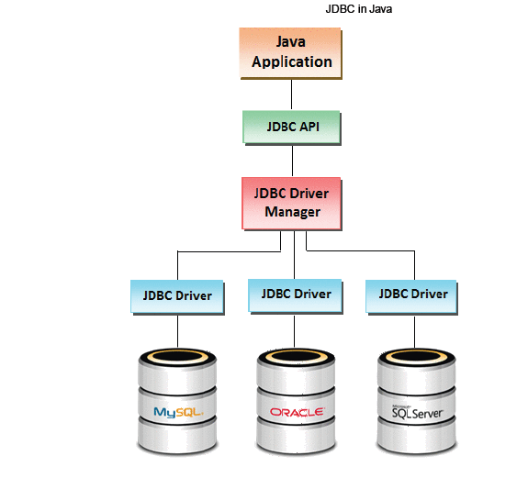

Classes In Jdbc
- DriverManager
- SQLException
- Types
- Date
- Time

Interfaces In Jdbc
- Connection
- Statement
- PreparedStatement
- CallableStatementResultset
- ResultSetMetaData
- DatabaseMetaData
- Driver
- Blob
- Clob

Steps to write JDBC Program
There are 6 steps to connect any java application with the database using JDBC. They are as follows:
- Load the JDBC driver class or register the JDBC driver.
- Establish the connection
- Create a statement
- Execute the sql commands on database and get the result
- Print the result
- Close the connection

1. Register the driver class
To registering the JDBC driver, use forName() method of Class class is used to register the driver class. This method is used to dynamically load the driver class.
There are 2 ways register the drivers
- Class.forName("fully qualified classname")
- DriveManager.registerDriver(object of driver class)

Syntax of forName() method
public static void forName(String className)throws ClassNotFoundException

Syntax
class.forName("Driver name");

2. Create the connection object
To connection between a java program and a database will be opened. To open the connection, we call getConnection() method of DriverManager class.
For getConnection() method we need to pass three parameters.
- url
- username
- password
url: url is used to select one register JDBC driver among multiple registered driver by DriverManager class.
username and password: username and password are used for authentication purpose.

Syntax of getConnection() method
public static Connection getConnection(String url,String name,String password)
throws SQLException

3. Create the Statement object
To transfer sql commands from java program to database we need statement object. To create a statement object we call createStatement() method of connection interface. The createStatement() method of Connection interface is used to create statement. The object of statement is responsible to execute queries with the database.

Syntax of createStatement() method
public Statement createStatement()throws SQLException

Example to create the statement object
Statement stmt=new createStatement();

4. Executing queries
Call any one of the following three methods of Statement interface is used to execute queries to the database and to get the output.
- executeUpdate(): Used for non-select operations.
- executequery(): Used for select operation.
- execute(): Used for both select or non-select operation.
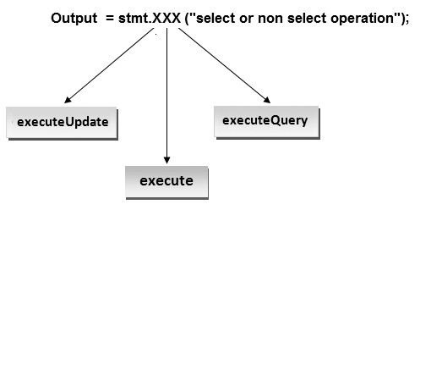

5. Print the result.

Syntax
System.out.println(output);
6.Closing connection : Close the connection.
By closing connection object statement and ResultSet will be closed automatically. The close() method of Connection interface is used to close the connection.

Syntax of close() method

Syntax of close() method
public void close()throws SQLException

Example for close connection
con.close();

JDBC driver
Jdbc API contains a set of classes and Interfaces where classes definition is provided by Sun Micro System and Interfaces Implementation are not provided. For interface Implementation classes will be provided by vendors, these set of classes are called Jdbc Driver Software.
A Driver software contains set of classes among these classes one class is driver class.
Driver class is a mediator class between a java application and a database.
(Image)
Java Application use Jdbc API and this API connect to driver class, then driver class connect to database.

Types of Jdbc Driver
JDBC Driver is a software component that enables java application to communicate with the database.There are 4 types of JDBC drivers, they are:
- Jdbc-Odbc Bridge Driver
- Native-API driver (partially java driver)
- Network Protocol driver (fully java driver)
- Thin driver (fully java driver)

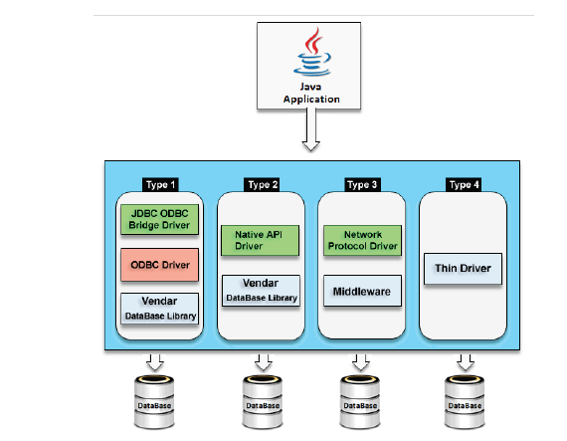

Short Description of Jdbc drivers
- Type 1 driver are database independent and platform dependent.
- Type 2 driver are database dependent and platform dependent.
- Type 3 driver are database independent and platform independent.
- Type 4 driver are database dependent and platform independent.
Driver | Database | Platform
Type – 1 | Independent | Dependent.
Type – 2 | Dependent | Dependent.
Type – 3 | Independent | Independent.
Type – 4 | Dependent | Independent.

JDBC Odbc Bridge Driver
This driver connect a java program with a database using Odbc driver. It is install automatically along with JDK software. It is provided by Sun MicroSystem for testing purpose this driver can not be used in real time application. This driver convert JDBC calls into Odbc calls(function) So this is called a bridge driver.
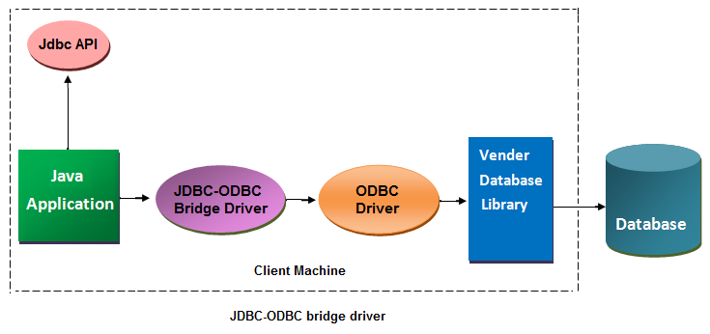

Advantage of bridge driver
- Easy to use
- It is a database independent driver
- Can be easily connected to any database.
- This driver software is built-in with JDK so no need to install separately.

Disadvantage of bridge driver
- It is a slow driver so not used in real time application
- Because of Odbc connectivity it is a platform dependent driver.
- It is not a portable driver.
- It is not suitable for applet to connect with database.

Native API Driver
Native API driver uses native API to connect a java program directly to the database. Native API id s C, C++ library, which contains a set of function used to connect with database directly. Native API will be different from one database to another database. So this Native API driver is a database dependent driver.
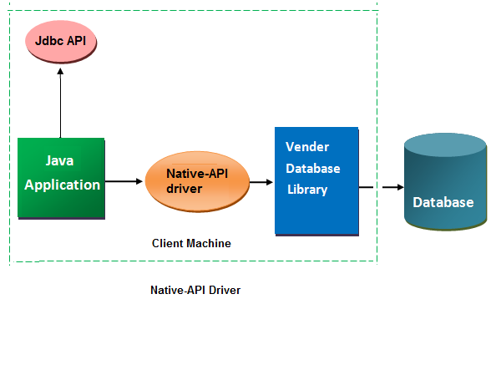

Advantage of Thin driver
- Native API driver comparatively faster than JDBC-ODBC bridge driver.

Disadvantage of Thin driver
- Native API driver is database dependent and also platform dependent because of Native API.

Network Protocol Driver in JDBC
The Network Protocol driver uses middle-ware (application server) that converts JDBC calls directly or indirectly into the vendor-specific database protocol. It is fully written in java..
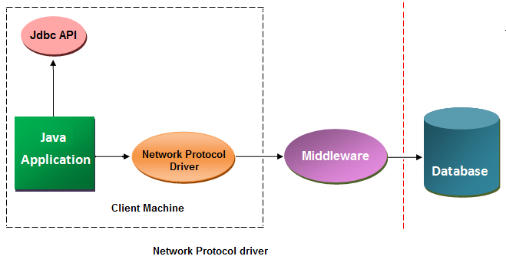

Advantage of Network Protocol driver
- No client side library is required because of application server that can perform many tasks like auditing, load balancing, logging etc.
- This driver is both database and platform independent driver

Disadvantage of Network Protocol driver
- Network support is required on client machine.
- Requires database-specific coding to be done in the middle tier.
- Maintenance of Network Protocol driver becomes costly because it requires database-specific coding to be done in the middle tier.

Thin Driver in JDBC
The thin driver converts JDBC calls directly into the vendor-specific database protocol. That is why it is known as thin driver. It is fully written in Java language.
This thin driver uses the following three information to connect with a database.
- Ip address of a machine (system), where the database server is running.
- Port number of the database server.
- Database name, also called SID (service ID).
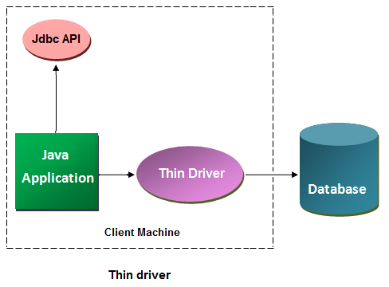

Advantage of Thin driver
- Thin driver is the fastest driver among all Jdbc drivers.
- No software is required at client side or server side.
- It is portable driver because it is platform independent.
- It can be used to connect an applet with the database.

Disadvantage of Thin driver
- Thin driver is a database dependent driver.

Why thin driver is database dependent driver ?
Because thin driver internally uses native protocol. Native protocol is a server dependent protocol it means the protocol can establish connection with a particular server only.
The following are the connection properties of oracle thin driver.
driver name: | Oracle.Jdbc.OracleDriver
url: | Jdbc:Oracle:thin@ipaddress:sid
name | system
password | tiger

How to Connect Java Application with Oracle Database

For connecting java application with the oracle database, we need to follow below steps. In this example we are using Oracle 10g as the database. So we need to know following information for the oracle database.
The following are the connection properties of oracle thin driver.
Driver Class: | Oracle.Jdbc.OracleDriver
Connection url: | jdbc:oracle:thin:@localhost:1521:xe
Username: | The default username for the oracle database is system.
password | Password is given by the user at the time of installing the oracle database.

jdbc:oracle:thin:@localhost:1521:x
- jdbc is the API
- oracle is the database
- thin is the driver
- localhost is the server name on which oracle is running, we may also use IP address
- 1521 is the port number and
- XE is the Oracle service name.
Note: You may get all above information from the tnsnames.ora file.

Create a table in oracle database
create table student(roll number(10),name varchar2(40));

Example to Connect Java Application with Oracle database
import java.sql.*;
class OracleCon
{
public static void main(String args[]){
try
{
//step1 load the driver class
Class.forName("oracle.jdbc.driver.OracleDriver");

//step2 create the connection object
Connection con=DriverManager.getConnection(
"jdbc:oracle:thin:@localhost:1521:xe","system","oracle");

//step3 create the statement object
Statement stmt=con.createStatement();

//step4 execute query
ResultSet rs=stmt.executeQuery("select * from student");
while(rs.next())
System.out.println(rs.getInt(1)+" "+rs.getString(2)+" "+rs.getString(3));

//step5 close the connection object
con.close();

}
catch(Exception e)
{
System.out.println(e);
}
}
}

Connection Interface in JDBC
A Connection is the session between java application and database. The Connection interface is a factory of Statement, PreparedStatement, and DatabaseMetaData i.e. object of Connection can be used to get the object of Statement and DatabaseMetaData. The Connection interface provide many methods for transaction management like commit(),rollback() etc.

Method of Connection Interface
 | method | Discription
1 | public Statement createStatement() | creates a statement object that can be used to execute SQL queries.
2 | public Statement createStatement(int resultSetType,int resultSetConcurrency) | Creates a Statement object that will generate ResultSet objects with the given type and concurrency.
3 | public void setAutoCommit(boolean status) | Used to set the commit status.By default it is true.
4 | public void commit() | saves the changes made since the previous commit/rollback permanent.
5 | public void rollback() | Drops all changes made since the previous commit/rollback.
6 | public void close(): | closes the connection and Releases a JDBC resources immediately.

Drivermanager Class of JDBC
The DriverManager class acts as an interface between user and drivers. It keeps track of the drivers that are available and handles establishing a connection between a database and the appropriate driver. The DriverManager class maintains a list of Driver classes that have registered themselves by calling the method DriverManager.registerDriver().

Methods of DriverManager Class
 | method | Description
1 | public static void registerDriver(Driver driver) | Used to register the given driver with DriverManager.
2 | public static void deregisterDriver(Driver driver): | Used to registered the given driver (drop the driver from the list) with DriverManager.
3 | public static Connection getConnection(String url): | Used to establish the connection with the specified url.
4 | public static Connection getConnection(String url,String userName,String password): | Used to establish the connection with the specified url, username and password.

Statement Interface in JDBC
The Statement interface provides methods to execute queries with the database.

Method of Statement Interface
 | method | Description
1 | public ResultSet executeQuery(String sql) | Used to execute SELECT query. It returns the object of ResultSet.
2 | public int executeUpdate(String sql) | Used to execute specified query, it may be create, drop, insert, update, delete etc.
3 | public boolean execute(String sql) | Used to execute queries that may return multiple results.
4 | public int[] executeBatch() | Used to execute batch of commands.

ResultSet Interface in JDBC
The object of ResultSet maintains a cursor pointing to a particular row of data. Initially, cursor points to before the first row.

Method of ResultSet Interface
 | method | Description
1 | public boolean next() | Used to move the cursor to the one row next from the current position.
2 | public boolean previous() | Used to move the cursor to the one row previous from the current position.
3 | public boolean first() | Used to move the cursor to the first row in result set object.
4 | public boolean last() | Used to move the cursor to the last row in result set object.
5 | public boolean last() | Used to move the cursor to the last row in result set object.

Difference Between PreparedStatement and Statement
If the sql command is same then actually no need to compiling it for each time before it is executed. So the performance of an application will be Increased. In this case PreparedStatement is used.
PreparedStatement Interface is derived Interface of statement and CallableStatement is derived Interface of PreparedStatement.
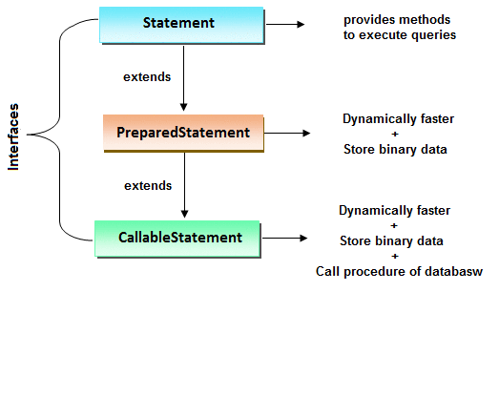

Why use PreparedStatement
We know that when working with Statement Interface of JDBC the sql command will be compiled first and then it is executed at database side even through the same sql command is execute repeatedly but each time the command is compiled and then executed at database. Due to this performance of application will be decreased So overcome this problem use PreparedStatement. In PreparedStatement, If the sql command is same then actually no need to compiling it for each time before it is executed.

In case of preparedStatement
- First sql command is send to database for compilation and then compiled code will be stored in preparedStatement object.
- The compiled code will be executed for n number of time without recompiling the sql command.
- The criteria to use preparedStatement is when we want to execute same sql query for multiple times with different set of values.
- Comparatively preparedStatement is faster than Statement Interface.

Difference between PreparedStatement and Statement
 | Statement | PreparedStatement
1 | Statement interface is slow because it compile the program for each execution | PreparedStatement interface is faster, because its compile the command for once.
2 | We can not use ? symbol in sql command so setting dynamic value into the command is complex | We can use ? symbol in sql command, so setting dynamic value is simple.
3 | We can not use statement for writing or reading binary data (picture) | We can use PreparedStatement for reading or writing binary data.

Create an object of PreparedStatement

Syntax
Connection con; // con is reference of connection
PreparedStatement pstmt=con.prepareStatement("sql command");

Why use '?' symbol in PreparedStatement
To pre-compile a command only syntax of the command is required so we can use '?' symbol for value in the command. '?' symbol is called parameter or replacement operator or place-resolution operator.

Syntax
PreparedStatement pstmt=con.prepareStatement("Insert into student_table value(?, ?, ?)");
Note: In PreparedStatement only '?' symbol are allow, no other symbols are allowed.
Note: '?' is only for replacing value but not for table name or column names.
Note: '?' symbol are not allowed in DDL operation.

Setting value
We call setxxx() methods to set the value in place of ? symbols, before executing the command. Here pass two parameters for setxxx(), where first parameter is index and second is value. XXX means any data type.

Syntax
pstmt.setInt(1,102);

Example of PreparedStatement
import java.sql.*;
import javax.sql.*;//PreparedStatement;
import java.util.*;
class PrepardTest1
{
Connection con;
void openConnection()throws Exception
{
Class.forName("oracle.jdbc.OracleDriver");
System.out.println("driver is loaded");
con=DriverManager.getConnection("jdbc:oracle:thin:@John-pc:1521:xe","system","system");
System.out.println("connection is opend");
}
void insertTest()throws Exception
{
PreparedStatement pstmt=con.prepareStatement("insert into student values(?,?,?) ");
Scanner s=new Scanner(System.in);
String Choice="yes";
while(Choice.equals("yes"))
{
System.out.println("enter student id");
int sid=s.nextInt();
System.out.println("enter student name");
String sname=s.next();
System.out.println("enter Student marks");
int marks=s.nextInt();

//setting the values
pstmt.setInt(1,sid);
pstmt.setString(2,sname);
pstmt.setInt(3,marks);
int i=pstmt.executeUpdate();
System.out.println(i+"Row inserted");
System.out.println("do you want to inset another row(Yes/no)");
Choice=s.next();
}//end while
pstmt.close();
}
void closeConnection()throws Exception
{
con.close();
System.out.println("connection is closed");
}
public static void main(String[] args) throws Exception
{
PrepardTest1 pt=new PrepardTest1();
pt.openConnection();
pt.insertTest();
pt.closeConnection();
}
}

Callablestatement in Jdbc
To call the procedures and functions of a database, CallableStatement interface is used.
CallableStatement is a derived Interface of preparedStatement. It has one additional feature over PreparedStatement that is calling procedures and function of a database.
Because of CallableStatement is inherited from PreparedStatement all the features of PreparedStatement are also available with CallableStatement.


Create object of CallableStatement
The prepareCall() method of Connection interface returns the instance of CallableStatement. To create a reference of CallableStatement we have two syntaxes one with command and the other is wih calling procedure or function.

Syntax of prepareCall() method
public CallableStatement prepareCall("{ call procedurename(?,?...?)}");

Syntax
CallableStatement cstmt=con.prepareCall("sql command");

Syntax
CallableStatement cstmt=con.prepareCall("{call procedure name or function name}");

Syntax
CallableStatement stmt=con.prepareCall("{call myprocedure(?,?)}");

